Chipotle Tofu Chilaquiles

https://minimalistbaker.com/chipotle-tofu-chilaquiles/

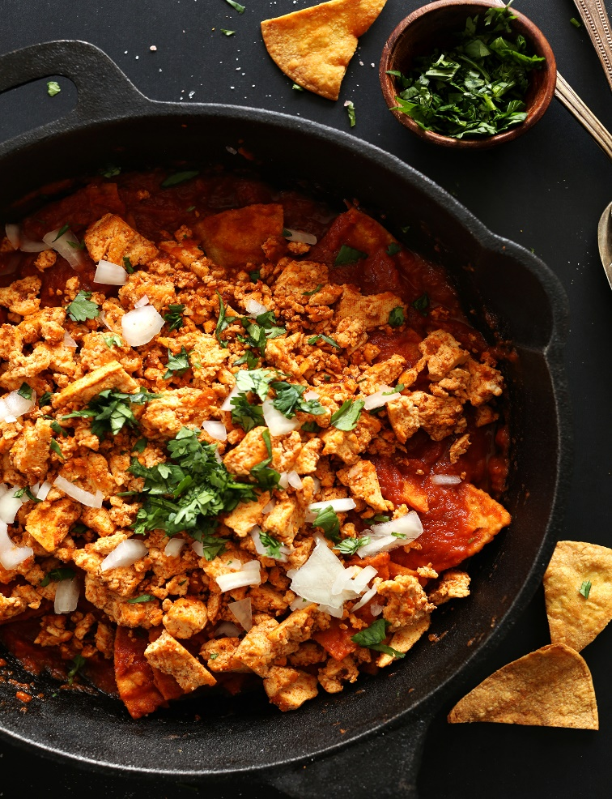
**Click link above to change serving sizes

Ingredients
US Customary – Metric
2 servings

FOR THE CHILAQUILES:
- 5 small yellow corn tortillas*
- 1/2 large white onion (diced)
- 2 cloves garlic (minced)
- 1 15-ounce can crushed tomatoes or tomato sauce
- 1 chipotle in adobo sauce (canned)
- 1 Tbsp adobo sauce (add more or less depending on preferred spice)
- 1/2 cup veggie stock

FOR THE TOFU:
- 8 ounces extra-firm tofu (drained and pressed in a clean towel for 15 minutes // I set a cast iron on top)
- 1/2 tsp cumin
- 1/2 tsp garlic powder
- 1/4 tsp chili powder
- 1/4 tsp sea salt

TOPPINGS (optional)
- Vegan Mexican Cheese
- Diced onion and/or fresh cilantro
- Salsa or hot sauce
- Lime juice

Instructions
    - Start by quickly pressing/draining your tofu in a clean kitchen towel with a heavy pot on top, and preheating oven to 350 degrees F (176 C).
    - IF BAKING YOUR OWN TORTILLAS: Lightly brush or spray both sides of your tortillas with olive or avocado oil and lightly dust them with sea salt. Stack and cut into triangles and arrange in a single layer on a large baking sheet. Bake for 10-12 minutes, flipping once halfway through, until crisp and just slightly golden brown. Set aside. If using regular chips, skip this step.
    - While chips are baking, heat a large skillet over medium heat and prep onion and garlic.
    - Once hot, add 1 Tbsp olive or avocado oil (amount as original recipe is written // adjust if altering batch size) and onion. Cook, stirring frequently, until soft and slightly browned – 3 minutes. Then add garlic and cook for 1-2 minutes more.
    - Add tomato sauce, diced chipotle and adobo sauce, and veggie stock. Heat until bubbly. Then reduce heat to low and simmer for 5 minutes.
    - Transfer sauce to a blender (optional). For a completely smooth sauce, blend well. For a chunkier sauce, pulse and leave some texture. Set aside.
    - Use a fork to crumble the tofu and place skillet back over medium heat (no need to rinse or wipe clean – the remaining sauce adds more flavor).
    - Add a bit of oil to the pan and then add tofu. Let lightly brown for 3-4 minutes, stirring once or twice. Then add seasonings (chili powder, salt, garlic powder and cumin) and stir. Cook for another 2 minutes, then remove from pan and set aside.
    - Add chips to the pan and pour over sauce, stirring quickly to coat. Then top with tofu scramble, fresh onion, and cilantro and serve immediately. Additional toppings might include hot sauce, lime juice, salsa and/or Vegan Mexican Cheese. Serves 2-3 as original recipe is written. Best when fresh.

