Ultimate Chicken SalaD
PREP TIME: 10 mins
COOK TIME: 15 mins
TOTAL TIME: 25 mins
SERVINGS: 6 servings
AUTHOR: Lisa Bryan
Chicken salad is a classic salad recipe with diced chicken, creamy mayonnaise, crisp celery, green onion, sweet grapes, and fresh herbs. Watch the video above to see how I make it!
Video Link: https://www.youtube.com/watch?v=cSAGdGSdE6k
Website Link: https://downshiftology.com/recipes/chicken-salad/

INGREDIENTS
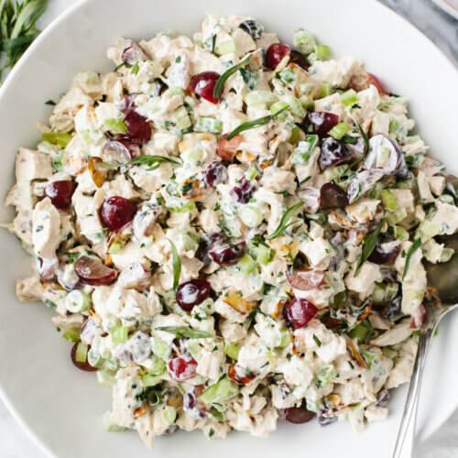
US Customary - Metric
- 2 lb boneless skinless chicken breasts
- 1/2 cup sliced almonds
- 1 cup mayonnaise
- 1 tablespoon dijon mustard
- 1 cup red grapes, quartered
- 2 stalk celery, diced
- 3 green onions (green and white parts), sliced
- 2 tablespoon chopped parsley
- 1 tablespoon chopped tarragon
- 1 lemon, juiced
- salt and pepper, to taste

INSTRUCTIONS

To Make the Poached Chicken
- Place the chicken breasts in a wide pot or pan and cover by about an inch with cold water. Season the water with salt. Optionally, you can add aromatics of your choice. Read my poached chicken recipe for more details.
- Turn the heat to medium until it reaches a gentle simmer. Then reduce the heat back to low and cover the pan.
- Let the chicken simmer for 8-12 minutes, or until the internal temperature reaches 160-165 degrees Fahrenheit.
- Remove the chicken and let it rest for a couple of minutes. Then chill in the fridge.

Chicken Salad Recipe
- Transfer the cooled chicken to a cutting board and dice it into 1/2-inch pieces.
- Then, slice and dice the celery, green onion, grapes, parsley and tarragon.
- Add those ingredients to a mixing bowl along with the mayonnaise, Dijon mustard, and lemon juice. Season with salt and pepper. Then mix everything together until it's well combined.
- Let it chill in the fridge until you're ready to serve.

