Mediterranean Chicken Salad Sandwich

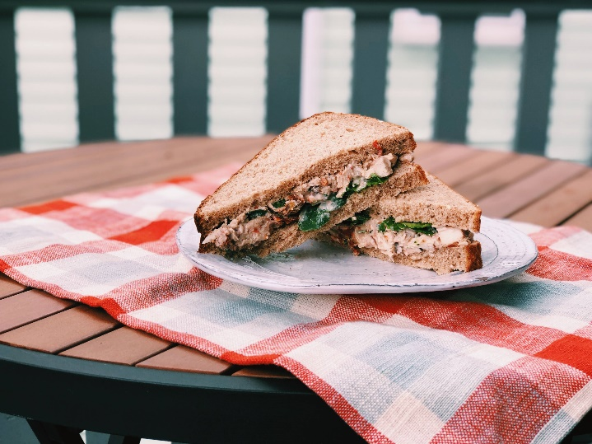
INGREDIENTS
- 1 cup plain Greek yogurt
- ¼ cup sundried tomatoes ﬁnely chopped
- 2 roasted red peppers, ﬁnely chopped
- 3 cups chopped cooked chicken breasts (from about 1 pound chicken)
- ¼ cup sliced or slivered almonds
- ¼ cup chopped fresh basil
- 1 cup spinach
- 8 slices whole wheat bread

INSTRUCTIONS
- Mix together the Greek yogurt, sundried tomatoes, roasted red peppers, chopped chicken, almonds, and basil in a medium mixing bowl until well combined.
- Portion ¼ of the chicken salad between 2 slices whole grain bread, putting a ¼ cup spinach into each sandwich as well. Serve immediately. (Leftover chicken salad can be stored in the refrigerator.)
An Oldways recipe, courtesy of Kelly Toups
https://wholegrainscouncil.org/recipes/mediterranean-chicken-salad-sandwiches

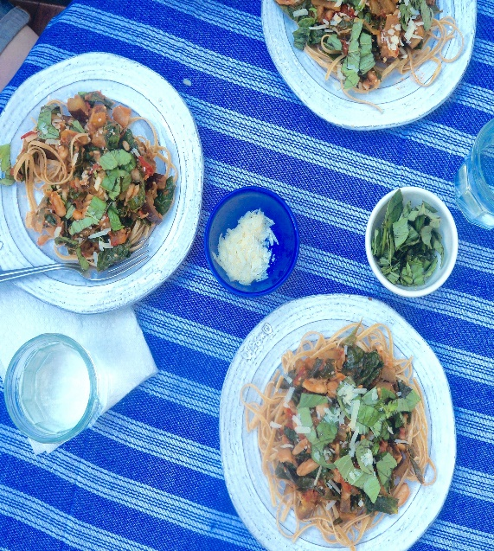
Summer Harvest Linguine with Cannellini Beans
Serves 4
https://kellytoups.com/category/recipes/

Ingredients:
- 8 oz whole wheat linguine
- 2 tablespoons plus one teaspoon olive oil, divided
- 1 medium onion, chopped
- 1 medium to large eggplant, chopped
- 4 large heirloom tomatoes
- 2 cloves garlic, finely chopped
- 1/2 teaspoon salt
- 1/2 teaspoon dried oregano
- 1 15 oz can cannellini beans (or other white bean), drained and rinsed
- 1 bunch Tuscan kale
- 1/4 cup grated Parmigiano Reggiano
- 1/4 cup fresh basil, cut or torn into ribbons

Method:
- Cook linguine according to package instructions. After draining, toss the pasta with one teaspoon olive oil (to prevent noodles from sticking) and set aside.
- Heat the remaining two tablespoons of olive oil in a large skillet over medium high heat. Add the onion and eggplant.
- While the onion and eggplant are softening, chop the tomatoes.
- Once the tomatoes are chopped, add them to the skillet (the eggplant will have absorbed all of the oil by this point, so the pan will need the liquid from the tomatoes).
- Add the garlic, salt, oregano, and cannellini beans, stirring occasionally.
- While the vegetables are cooking, remove the kale leaves from their stems and tear or chop into bite sized pieces.
- Add the kale to the skillet, stirring until kale is wilted.
- Dive the pasta among four plates, then top each plate with the vegetable mixture. Garnish each plate with one tablespoon each parmigiano reggiano and fresh basil.

