# **Healthy Simple Snack Ideas**

**Apple + String Cheese Reduced Fat Wheat Thins + Peanut Butter**

**Any type of fruit Hard Boiled Egg**

**Carrots/Celery + Hummus Yogurt (can be dairy-free/**

**check for lowest sugar content)**

**Unsweetened Apple Sauce** **Granola/ handful of nuts**

**If you’re on the go and want healthier bar options, these are what a dietician has recommended….**

**RX Bars LARABAR**

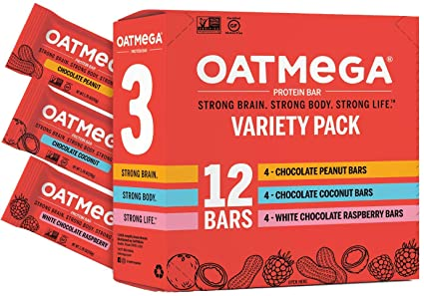

**Perfect Bar Oatmega**

**Health Warrior Chia Bar 22 Days Nutrition Bar**