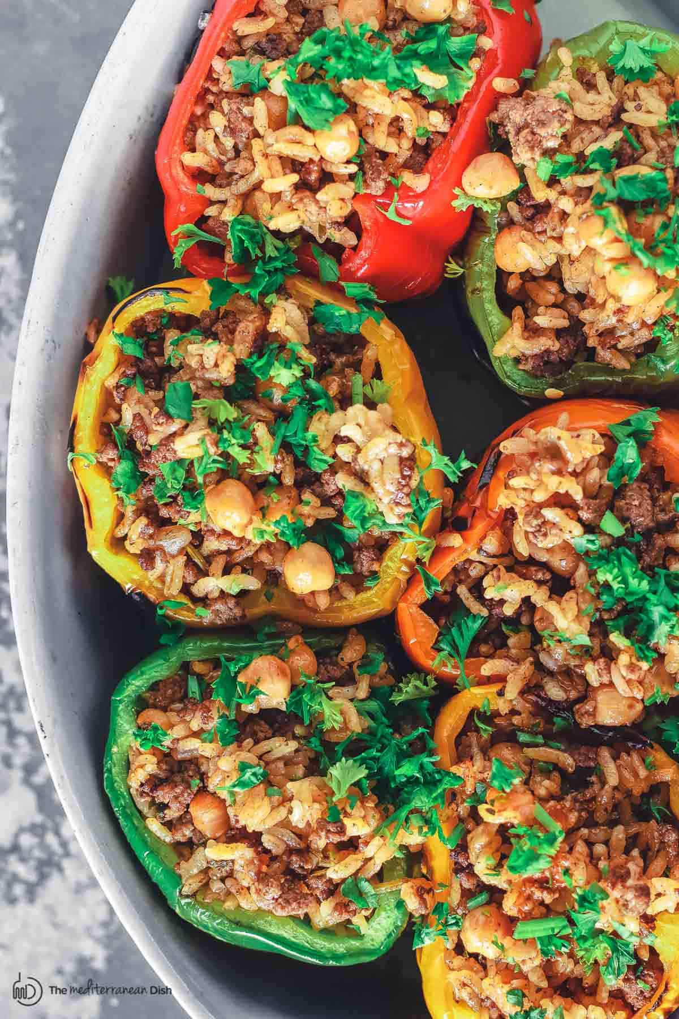
Greek Style Stuffed Peppers

DESCRIPTION
You’ll love these stuffed peppers, prepared Greek-style and stuffed with a perfectly seasoned meat mixture with rice and chickpeas and fresh herbs. You can prepare parts of this recipe ahead of time, and you can even freeze leftover stuffed peppers! Serve them as the main course or a side dish.

INGREDIENTS
- Greek extra virgin olive oil (I used Private Reserve EVOO)
- 1 small yellow onion, chopped
- 1/2 lb ground beef
- Kosher salt + black pepper
- 1 tsp ground allspice
- 2 garlic cloves, minced (or 1 tsp garlic powder)
- 1 cup cooked or canned chickpeas, drained and rinsed
- 1 small bunch fresh parsley, chopped (about 1 cup packed fresh parsley. Or a mixture of chopped fresh parsley and fresh dill)
- 1 cup white rice, soaked in water for 20 to 30 minutes, then drained
- 3/4 tsp hot or sweet paprika
- 1/4 cup tomato sauce
- 2 1/4 cup water
- 6 bell peppers, any colors, tops removed and cored
- 3/4 cup chicken broth (or water)

INSTRUCTIONS
- Cook the meat & chickpeas. In a medium heavy pot, heat 1 tbsp of extra virgin oil. Sauté the chopped onions until golden. Now add the meat and cook over medium-high heat, stirring occasionally, until deeply browned. Season with salt, pepper, allspice, minced garlic (or garlic powder). Stir in the chickpeas and cook briefly.
- Add rice etc. and cook. To the same pot, now add the parsley, rice (which had been soaked in water and drained), paprika, and tomato sauce. Stir to combine. Add the water and bring to a high simmer until the liquid has reduced by half. Then turn the heat to low, cover and cook for 20 minutes or until the rice is fully cooked and no longer hard nor too chewy. Taste and adjust seasoning to your liking.
- Grill the peppers. While the rice is cooking, heat a grill or indoor griddle or skillet over medium-high. Grill the bell peppers for 10-15 minutes, covered, and turning over as needed so that the peppers will soften and gain some color. Remove from heat and set aside to cool briefly. (Or when you reach the step, just cook peppers longer in the oven because they need to be tender, not crunchy).
- Preheat the oven to 350 degrees F.
- Assemble stuffed peppers. Assemble the bell peppers open-side up in a baking dish filled with 3/4 cup broth or water. Fill each of the bell peppers with the cooked stuffing mixture of meat, rice and chickpeas.
- Cover and bake. Cover the baking dish with foil (making sure the foil does not touch the stuffed peppers) and place the dish on the middle rack of your heated oven. Bake for 20-30 minutes.
- Remove from the oven and garnish with parsley, if you like, and serve.
- To serve stuffed peppers as a main dish Greek-style, add Tztaziki sauce and Greek salad for sides.

NOTES
- Variations for Stuffed Bell Peppers: If you like you can replace the ground beef with ground turkey or ground chicken. Or you can make these stuffed peppers vegan by eliminating the meat all together. And to try different flavors, you can replace ground allspice with ground cumin or Italian seasoning. This is a dairy free stuffed pepper recipe, but if you want to add cheese, a sprinkle of crumbled feta added at the end is a good option.
- To Prepare Ahead: You can prepare the rice mixture one day in advance if you like by following steps #1 and #2. Let the rice cool completely before storing in the fridge. And you can also prepare the peppers per step #3. Store the peppers in the fridge separately once cooled. The next day, you can assemble the stuffed bell peppers and bake (steps #5 and #6). It may help to bring the stuffed peppers to room temperature before baking.
- Can you freeze cooked stuffed peppers? First, be sure to cool the stuffed peppers completely. You can portion and store them in freezer-safe containers and freeze for 1 to 2 months. Thaw in fridge overnight, and warm up in a medium-heated oven (it helps to add a little bit of liquid to your baking dish and cover the peppers before placing in oven.)
*Recipe from https://www.themediterraneandish.com/stuffed-peppers-recipe/

