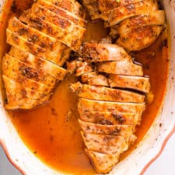
Oven Baked Chicken Breast

https://ifoodreal.com/baked-chicken-breast/

Ingredients
- 2 lbs boneless & skinless chicken breasts
- 1 tbsp avocado or olive oil
- 1 tsp smoked paprika
- 1 tsp garlic powder
- 1 tsp oregano
- 1/2 tsp salt
- Ground black pepper, to taste

Instructions
- Preheat oven to 450 degrees F.
- In a medium baking dish, place chicken, drizzle with oil and sprinkle with smoked paprika, garlic powder, oregano, salt and pepper. Using tongs or hands, move chicken around to coat on all sides evenly (I place bottom of breast on top of seasoned one and then swoosh around).
- Bake for 25 minutes (thinner) to 35 minutes (2″+) or until 150 degrees F internal temperature. Remove from the oven, cover with foil or lid, and let rest for 10 minutes for the juices to settle (don’t skip!).
- Slice against the grain and serve along any side with a salad. Meal prep for the week, use in salads and casseroles.
**Note: SMOKED paprika is the best for this one!

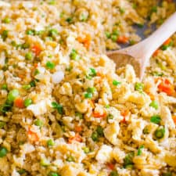
Cauliflower Fried Rice
https://ifoodreal.com/cauliflower-fried-rice/

Ingredients
- 1 small onion, finely chopped
- 1 garlic clove, minced
- 1 tbsp ginger, minced
- 1 large carrot, diced
- 1 cup peas, fresh or frozen
- 2 tbsp toasted sesame oil
- 4 eggs, large
- 16 oz bag of cauliflower rice, fresh or frozen
- 1 tbsp honey or maple syrup
- 3 tbsp soy sauce or coconut aminos
- 3 onion sprigs, finely chopped

Instructions
- Preheat large ceramic non-stick skillet on medium-high heat and swirl oil to coat. Add onion, garlic, ginger, carrot, peas and cook for 4-5 minutes, stirring occasionally.
- Push vegetables to the side and add eggs. Cook until scrambled, stirring constantly.
- Add cauliflower rice (don’t thaw frozen one), stir and cook until warmed through.
- Push cauliflower rice to the side and add honey and soy sauce, stir well. Sprinkle with green onion and serve.
Here’s a video: https://www.youtube.com/watch?v=MbiX1EkYaak
Store: Refrigerate in an airtight container for up to 3 days.

Notes from the author:
You can make your own cauliflower rice, but I prefer store-bought because it saves time and its coarse texture resembles more real rice than homemade. I swear my kids’ eyes were a size of a saucer when I told them it’s not real rice.
Make cauliflower chicken fried rice. Use ground chicken or finely chopped boneless chicken breast and sauté first in a pan before adding other ingredients. Pork works the same way.
Make shrimp cauliflower fried rice by cooking diced raw shrimp first. Remove it onto a plate, follow the recipe and then add cooked shrimp back. If you use cooked shrimp, dice, and add it at the end of cooking the recipe.
Make spicy cauliflower fried rice by adding a pinch of red pepper flakes or a few teaspoons of sriracha.

