Bumble Bee Breath Breathing Technique
For stress and anxiety
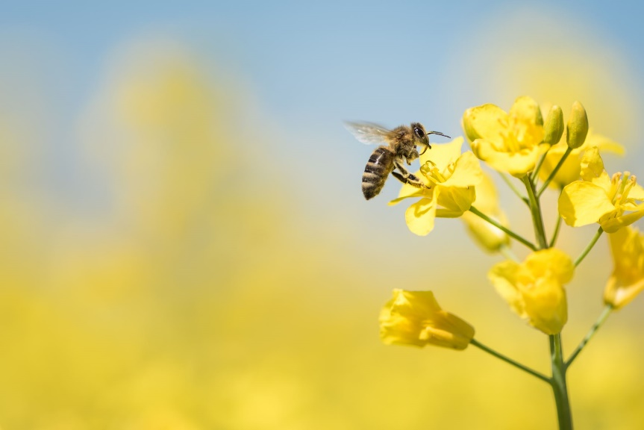

1) Begin in Sitting Mountain Pose with a tall, straight spine. Or sit on a chair with feet firmly planted on the floor, spine straight. Take a slow, deep breath in through your nose before exhaling out to “Hummmmmm,” as long as possible.
2) Try it again, but this time with your eyes closed. Focus on the humming sound. Notice the vibration created in your lips.
3) Try the same breath again with eyes closed and ears blocked with your hands. To do this use three fingers to block eyes and your thumbs to block your ears. Notice your focus go inward where there is peace and calm. Repeat this breath several times.

https://www.youtube.com/watch?v=yPy5Hn_9eiY

