Wild rice and wild mushroom pilaf with fresh herbs
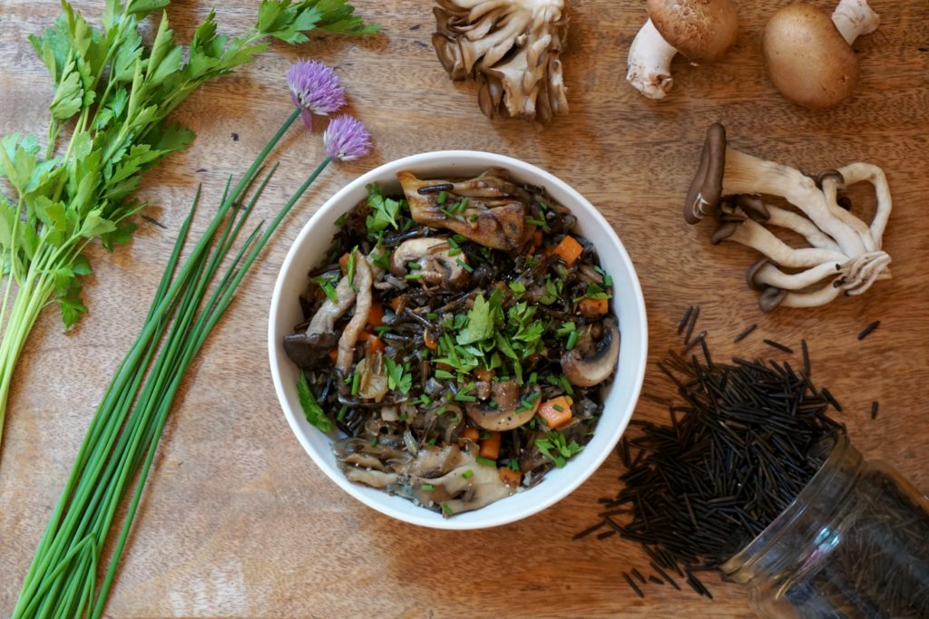
Wild mushrooms and wild rice are a delicious match. Both are savory and slightly nutty and shine when seasoned with sage, fresh parsley, and fresh chives.
Ingredients
- 1 cup wild rice
- 3 cups water or broth
- 3 tbsp butter
- 3 cloves shallots, finely sliced
- 2 cloves garlic, minced
- ½ tsp sea salt
- 3 cups mixed wild mushrooms, washed and trimmed
- 1 tsp dried sage
- 3 tbsp fresh parsley leaves, finely minced
- 3 tbsp fresh chives, finely minced
- freshly cracked pepper to taste
Directions
First, cook the wild rice: Add water or broth to a pot and bring to a boil. Add wild rice, cover the pot, and cook until rice is soft (most of the kernels will have split), about 40-45 minutes. Simmer or drain off any excess liquid. Set aside.
Add butter (or coconut oil) to a large skillet over medium-high heat. Once it's sizzling, add shallots, garlic, and salt, and cook until softened and fragrant, about 2 minutes. Then, add carrot, assorted mushrooms, and sage. Cook until softened, about 10 minutes.
Add the cooked wild rice to the cooked vegetable mixture and toss to heat. Once warmed, remove from heat and add parsley and chives; toss to combine. Top with freshly cracked pepper and serve.

