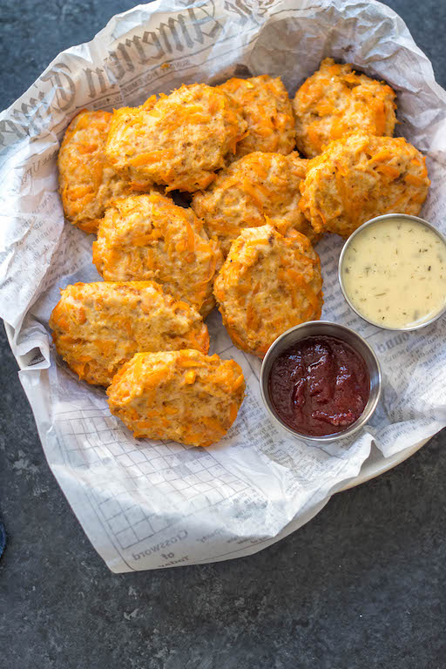
Sweet Potato Chicken Nuggets

https://www.wholekitchensink.com/sweet-potato-chicken-nuggets/

Ingredients
- 1 pound ground chicken
- 2 cups shredded sweet potatoes (about 2 medium sweet potatoes, peeled and shredded)
- 3 tbsp almond flour
- 1 tbsp chili powder
- 2 tsp garlic powder
- 2 tsp dried minced onion (or 1 tsp onion powder)
- 1 tsp smoked paprika
- 1 tsp salt

Instructions
- Preheat the oven to 350 degrees F. and spray a baking sheet with a little bit of cooking oil, or lay down oven safe parchment/baking paper
- Combine all the ingredients in a large mixing bowl until the sweet potato and spices are incorporated well
- Using your hands, form them into the nuggets or “poppers”. They should be about 1/4 inch-1/2 inch thick, in the shape of an oval or “flat egg shape”
- Place each formed nugget directly onto the sheet pan, in even rows with space between each, and continue until all of the chicken mixture in the mixing bowl is gone
- Next, put the sheet pan into the oven and bake for 25 minutes, flipping halfway through
- Remove from the oven and serve with your favorite dipping sauce
- If you want them to be a bit crisper, put them under the broiler for about 3 minutes, or crisp them up on a fry pan over medium-high heat for about 2 minutes on each side

Notes
- If the chicken is too sticky to form, you can place the mixing bowl into the fridge for 20-30 minutes. This will help to make it easier to work with when forming it into the nuggets.

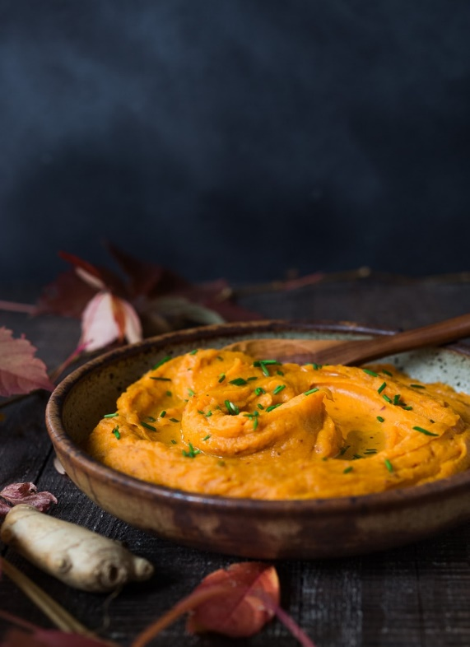
Mashed Sweet Potatoes With Ginger

https://www.feastingathome.com/mashed-sweet-potatoes-with-ginger/

Ingredients
- 2 lbs yams (or sweet potatoes) sliced into ½ inch thick disks, skin on
- water
- 2 tablespoons coconut oil, butter, ghee, or olive oil
- 1 shallot, finely diced
- 1 tablespoon fresh ginger, grated or paste
- 1 garlic clove, minced
- 1 teaspoon salt
- pepper to taste
- 1 teaspoon apple cider vinegar

Instructions
Slice sweet potatoes into disks and place them in a pot, cover with water, bring to a boil, cover with lid and simmer 12-15 minutes.
When the sweet potatoes are fork tender, drain, saving the water. In the same pot, heat olive oil, butter or coconut oil over medium heat and add shallots, ginger and garlic, stirring until fragrant and golden about 2-3 minutes.
At this point, you could add the sweet potatoes back into the pot and mash ( using a potato masher) adding some of the reserved sweet potato water to loosen it, or place it all in a food processor to whip until silky smooth.
I usually add about ½ cup liquid for a looser, almost saucy consistency. Season with the salt, pepper and apple cider vinegar.
Top with maple pecans for a crunchy texture.

