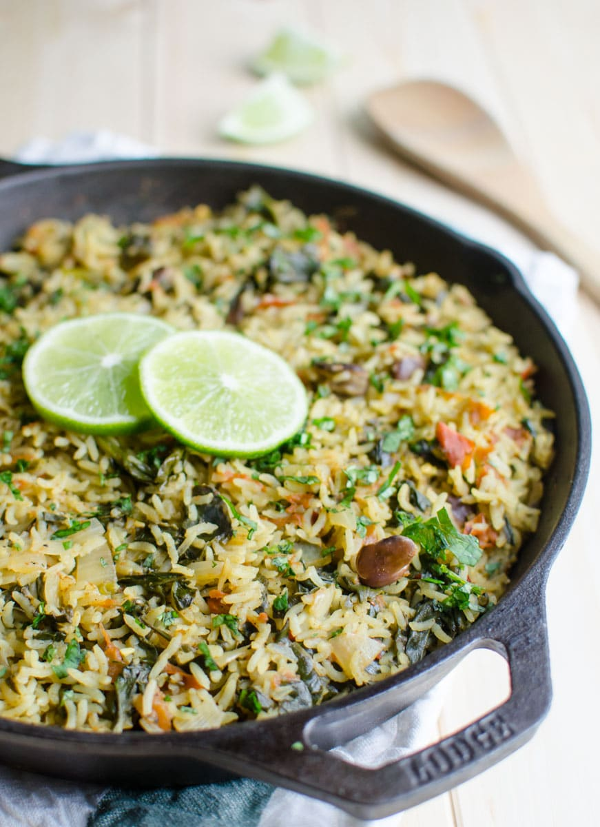
Spinach Rice
Healthy spinach rice loaded with proteins, fibers and vitamins. It is a one pot meal that takes about 30 min to prepare. Ideal for busy times.

Prep Time 10 minutes
Cook Time 20 minutes
Total Time 30 minutes
Servings : 3
Calories : 350kcal

Ingredients
- 1 cup white rice (rinsed and drained)
- 2-3 cups fresh baby spinach
- 2 Tomatoes diced
- 1 medium onion diced
- 2-3 cloves garlic minced
- 1 cup Pinto beans canned (rinsed and drained)
- 2 cup low sodium chicken stock (or vegetable stock or water if vegan)
- 1 1/2 tsp curry powder
- 1 tsp avocado oil or other cooking oil
- salt and pepper

Instructions
- Heat oil in a large skillet on medium heat. Add garlic and sauté until fragrant for about 30 sec.
- Add onion and sauté until translucent. Then add diced tomatoes and cook them until they soften for about 3-4 mins.
- Add spinach, beans, rice and cook for a couple of minutes. Now add water, chicken stock or vegetable stock (if vegan) and bring the mixture to a boil.
- Season with curry powder, salt and pepper. Adjust salt and pepper according to taste.
- Simmer the rice mixture for 18-20 min (or until rice is tender) on low heat with lid on.
- Turn off the heat and serve warm to enjoy this nutritious spinach rice.

Source:
https://www.watchwhatueat.com/one-pot-spinach-rice/

