Happy 4th of July!

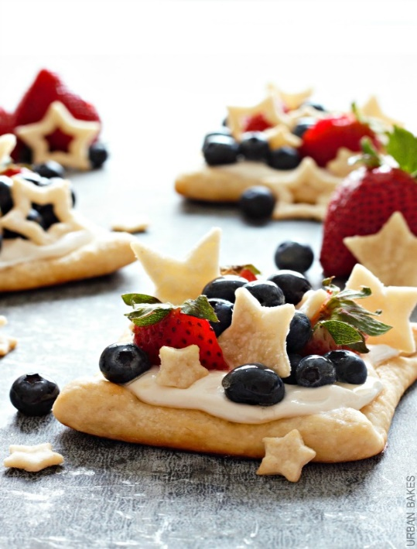
Starstruck Berry Marshmallow Pies
https://urbanbakes.com/starstruck-berry-marshmallow-pies/
INGREDIENTS
CRUST
- 1 box Pillsbury refrigerated pie crusts, softened
- 1 teaspoon milk
- 2 teaspoons granulated sugar
FILLING
- 8 oz. fat-free cream cheese
- 7.5 oz (half 13 oz tub) marshmallow crème
- 1–2 teaspoons lemon peel, grated
TOPPING
- 1 cup fresh blueberries
- 1 cup fresh strawberries, sliced
- 2 tablespoons honey
- 1 teaspoon lemon juice

INSTRUCTIONS
- Heat oven to 450 degrees F. On a lightly floured surface, unroll pie crusts. Use a rolling pin to evenly flatten edges.
- From each pie crust, cut out one large square and cut again in half. From the four halves, cut again to make a total of 8 4 1/2-inch squares.
- Roll all sides of each crust about 1/2-inch inward towards the center to create a lip to hold the filling. Lightly brush edges with milk. Sprinkle with sugar.
- Bake 6 to 8 minutes or until lightly golden brown on an ungreased baking sheet. Remove crusts from baking sheet and cool on a wire rack.
- Meanwhile, cut out a variety of stars. Brush each star with milk. Sprinkle with remaining sugar.
- Bake stars on an ungreased baking sheet for 2 to 3 minutes or until lightly golden brown. Remove from baking sheet and allow to cool.
- In a medium bowl, beat cream cheese until fluffy. Fold in marshmallow crème and grated lemon peel.
- Evenly spread 2 to 3 tablespoons of filling onto each cooled pie crust. Top with blueberries and strawberries. Insert stars throughout in between berries.
- In a small bowl, mix together honey and lemon. Lightly brush glaze over berries. ENJOY!

NOTES
- Full-fat versions of ingredients may be substituted for fat-free ingredients.
- If marshmallow crème is unavailable, beat 1/2 cup whipping cream until stiff peaks form. Fold into beaten cream cheese.
- Any variety of berries may be substituted for blueberries and/or strawberries.

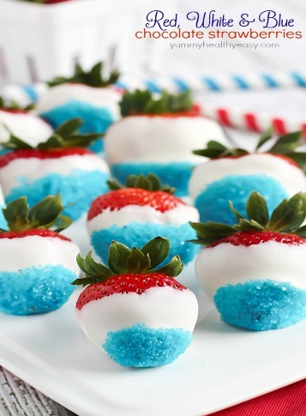
Red, White & Blue Chocolate Strawberries
https://www.yummyhealthyeasy.com/patriotic-white-chocolate-strawberries
INGREDIENTS
- Strawberries
- White chocolate
- Blue sprinkles
- Wax or parchment paper
INSTRUCTIONS
  - Melt white chocolate as instructed on the package. Dip strawberries in melted chocolate and then lightly dip in blue sprinkles. Set on wax or parchment paper to harden.
  - Repeat until you get the quantity of strawberries desired. Serve and devour!

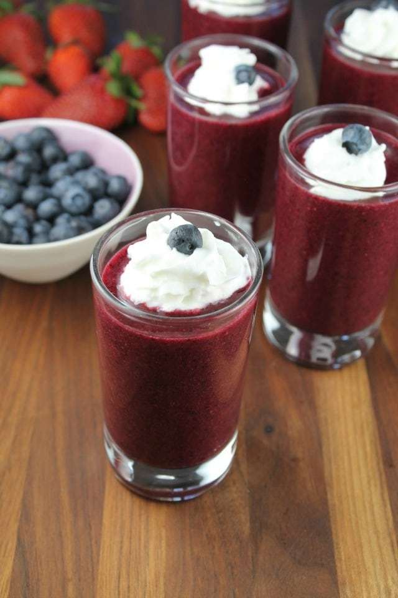
Berry Soup Dessert Shooters
INGREDIENTS
- 1 1/2 cups sliced strawberries
- 1 cup sliced peaches
- 1 cup blueberries
- 1/2 cup blackberries
- 1/3 cup honey
- 1 tablespoon lemon juice
- 1/4 teaspoon ground cinnamon
- whipped cream and fresh berries for garnish
INSTRUCTIONS
- Add all ingredients to a medium saucepan and place over medium-high heat, stirring often. Bring mixture to a boil and remove from heat.
- Allow mixture to cool. Place in a blender and blend until smooth.
- Chill until ready to serve.
- Garnish with whipped cream and fresh berries if desired.

NOTES
Fresh, frozen or canned fruit can be used. Recipe is easily doubled for a crowd.
https://www.missinthekitchen.com/berry-soup-dessert-shooters/

Skinny Chocolate Bark
https://www.delish.com/cooking/recipe-ideas/recipes/a45361/skinny-chocolate-bark-recipe/
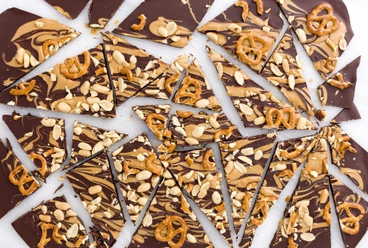
INGREDIENTS
- 24 oz. dark chocolate (at least 60 percent cocoa)
- 1 c. natural peanut butter, warmed
- 1 c. unsalted peanuts, chopped
- 1/4 c. pretzels

INSTRUCTIONS
- Line a baking dish or sheet with parchment. In a small glass bowl, heat dark chocolate in the microwave on low heat, stirring every 30 seconds, until melted. Pour into prepared dish, tilting so it fully covers the bottom of the dish.
- Drizzle over peanut butter, then drag a toothpick over the peanut butter in the opposite direction of the drizzle, creating a swirl.
- Top with peanuts and pretzels and refrigerate until firm, 1 hour. Break into pieces and serve. (Bark can be stored in a resealable container up to 2 weeks.)

